MARKETING PROPOSAL FOR “SELCO INDIA”

Assignment Taken
To propose a marketing plan for SELCO India for major three agendas:
- Product Line Expansion
- Sales Network Expansion
- Energy Service Centres Expansion

Case Understanding
SELCO India is a social enterprise headquartered in Bangalore that offers solar-powered solutions to India's poor citizens for their needs. The core tenet and mission of SELCO is a very profound notion that by empowering the poor to become productive individuals, their economic circumstances can be significantly improved. One of the most significant challenges has been their lack of access to clean and cost-effective energy sources. Even in today's time, a majority of the rural population depends on ineffective sources of energy. SELCO made repeated efforts to address the issue by providing them access to clean and pollution-free solar energy. However, it becomes an economically unviable choice given the typical income of a rural household. After facing financial losses in the initial years, Mr. Harish Hande was able to restructure the business with the aid of the International Finance Corporation (IFC), the World Bank's commercial finance division in 2008. SELCO India continued to be a for-profit company, but Mr. Hande was able to find new investors who were more supportive of its objectives. Additionally, Mr. Hande was able to maintain his sales and service business, including its core of highly driven workers. Given India's diverse population, where 40 crore members of the low-income category are still unable to avail benefits of accessible and sustainable energy solutions, SELCO India needs to expand its reach. This gap necessitates that SELCO India's services be expanded and scaled up to provide the advantages of solar energy to more people. Without compromising its mission to serve India's underprivileged population, SELCO seeks to expand its business. We need to prepare a detailed marketing proposal for SELCO India for its further business expansion.

Business Case Scenario: Solution Summary
Under the marketing proposal, we first need to analyze the company on strategic terms using SWOT and Porter’s Five forces model. We strongly need to focus on Knowledge sharing, feedback and complaint redressal, new product development, and Sales & ESC network expansion. Target market needs to be identified so as to convert more customers towards solar energy usage. Once the market has been penetrated using promotions and a marketing mix strategy, we can focus on product expansion so as to provide more product line variety to the end users. A smooth operational setup in the creation of an area will aid in the smooth expansion of SELCO. Sales network expansion will enable us to create more jobs in the market which will ultimately benefit the people and economy of the country. Inculcating, acquiring, and exploiting advanced technologies for production will lower the cost of production and hence, will benefit the low-income group people.

Business Case Solution

SELCO India
Principle Objective | To empower the poorest of India whose needs were largely ignored by service providers; by providing customized power solutions to its customers
Vision | Delivering Last Mile Sustainable Energy  Solutions that Improve Quality of Life and  Socio-Economic Development for the Poor
Philosophy | Underserved communities should be part of the solution design process

SWOT Analysis

STRENGTHS | WEAKNESSES
- Renewable energy-based resource  - Strong domestic demand  - Backed by the banks and financial institutions for funding and financial support  - Low cost production  - Technical, Technological and Innovation expertise  - Efficient labor and good networking in existing market  - Effective Management | - Capacity to handle limited orders presently  - Weak market presence  - Lack of industrial partners  - Need to enhance R&D
OPPORTUNITIES | THREATS
- Use of e-commerce and social media for direct marketing and promotions  - Govt. aided initiatives and funding  - Expansion through partnerships and collaborations  - Product line expansion and diversification | - High R&D expenses for few products  - Technical challenges with changing scenario  - Demand Supply gap

Porter’s Five Forces Analysis
Threat of new entrants | Threat of new entrants is low as the cost of generating renewable energy is very high; for example: the cost of setting up a solar panel etc; which makes entry of new players highly difficult.  Due to the high amount of investment needed, entering the energy business sector is challenging task. It requires significant upfront investment from new players, and scaling up is also extremely challenging. It would be challenging for the new rivals to compete on pricing. The costs of scaling up operations, pricing, and concerns with intellectual property rights would be significant for new competitors. Additionally, because SELCO has already established a reputation for itself in the market, it will be challenging for new competitors to swiftly create substantial distribution capabilities and market penetration.
Bargaining power of suppliers | Bargaining power of suppliers is medium as it is a relatively niche sector and the suppliers are therefore limited, so they enjoy some bargaining power. But the power is not too high as the order value is too high.  The suppliers of the primary energy components have the power to affect SELCO's pricing. This includes the running chassis, batteries, energy management system, integrated power system, and climate control seats, etc. SELCO should consider their future intentions to identify additional potential suppliers in the sector because this can be dangerous. Alternative inputs' accessibility can aid in reducing this influence. Decreased supplier influence can also be achieved with the option to switch supplier costs.
Bargaining power of buyers | Bargaining power of buyers is high as the cost of switching to a non-renewable energy source is low, and customers will easily switch if they find another cheaper source of energy.  When choosing to buy SELCO over other brands, the buyer has a significant degree of influence. However, there aren't many strong competitors in the domestic market to sway consumers. Price would undoubtedly persuade a customer to choose SELCO above other brands on the global market. This results from SELCO's products being on par with well-known brands in terms of quality and technology.
Threat of substitutes | Threat of substitutes is going to remain high as long as other non-renewable sources of energy remain cost-effective.  If cheaper alternatives to the company's products are available, it could pose detrimental effect on SELCO India. Solar or hydrogen energy are two alternatives in the energy sector that are now available. The market entry of these new energy technologies that provide lower prices could impede SELCO's sales. But the truth remains that solar energy is expensive, making it unattractive to consumers. The cost of a solar energy is prohibitively high and recovery will be over a long period of time. So, we can say that there is no risk of low-cost replacement products entering the energy sector and undermining SELCO's ability to generate sales.
Rivalry | As the sector is relatively new and players are still establishing themselves in the industry; the sector has still not reached the stage of competition. Therefore, competitive rivalry is quite low.

Objectives to be addressed:
The three main objectives to be achieved and addressed are:
- Expansion of the Product Line
- Expansion of the sales network
- Expansion of the Energy Service Centres

Our Focus

Knowledge sharing, feedback and complaint redressal | Constant feedbacks, redressal and knowledge sharing helps in understanding the clients’ requirements better in terms of cost, lighting and equipment solutions, quality of products and services offered. This further helps in developing better marketing initiatives for the customers.
New Product development | SELCO will provide customized products and services as per the local requirements to tap the specific clients’ needs. This will also help in word-of-mouth advertising, better staff-client interactions, and faster product development as per the feedbacks
Financial solutions and offers to appeal to the Clients | SELCO can connect and work with local banks, entrepreneurs, villagers etc. to facilitate quick and effective bank loan facilities to the clients. This will also enhance bank-client relationship and enhance the sales and solar based entrepreneurship among the villagers using banking practices.
Constant interactions with the suppliers | SELCO can work with the local suppliers, salespersons who will help in faster response to customer services and aid in product refinement as per the customers’ needs. This will also lead to quicker response to client issues.
Partnerships and Collaborations | SELCO has to continuously identify new needs, work in unison with suppliers, facilitators and customers. This can be done by working closely in CSR Initiatives, partnering with the community level organizations, engaging in community-based activities to build trust and network. SELCO has to focus on engaging the locals (local population, local institutions, government setups, CSOs,16 local market players, etc.) across the value chain as employees, customers, suppliers and entrepreneurs. This requires ongoing focus on local skill building (trainings) and local capacity building (entrepreneurs). The local engagement will help the companies in building awareness and trust as well as in bringing cost-efficiency to the overall value-chain.
Focus on end-to-end Solutions and Scalability | SELCO need to supplement the product/service offering with after-sales support and financing support with a clear scalability approach. This helps to neutralise the operational and infrastructure costs at one end; and multiply the revenues and social impact at the other end.

Marketing Plan Process

OPERATIONAL FLOW CHART

TARGET POPULATION:

Promotional Strategy
Promotional mix is a set of marketing activities that are intended to interact with target audience in order to achieve the institutional promotional objectives (Kotler and Keller, 2006). The different types of promotional activities that SELCO India as a company can consider are:
ADVERTISING
SELCO India in the present context to promote its solar energy solutions, can advertise using the following media:
- Radio (specific channels of Karnataka, Bihar, Tamil Nadu, Maharashtra states)
- Local dailies and TV Channels (both local vernacular and English)
- Out of home advertising (hoardings, danglers, bunters, leaflets, banners etc.)
- Short videos for movie theatres and local magazines (both local vernacular and English)
- Sponsorship of local shows and casting short Interview on TV & Radio highlighting the Accolades and Testimonials of the company.
- Word of Mouth advertising
- Activities like Conferences and Trade Fairs for Solar Exhibitions, Collaboration with IRMA (prominent institute working in rural areas)
These media should communicate that SELCO as a brand also offers convenience of solar energy solutions at affordable prices, which will help in building top of mind recall of solar energy as a value-offering. In addition to introducing these as a value-offering, SELCO can also explicate the benefits of solar energy solutions which is a crucial aspect for consumers who seek utilitarian value.
Further the advertisements should communicate a clear brand personality which will help in building relationships with consumers.
PERSONAL SELLING
Personal selling can be either door-to door campaigning or cold-calling in SELCO's areas of operation. Further, sales persons can be deployed at various touch-points (like local markets, melas, community gatherings etc.) in the area of sales as per the geographical data. Residents of the same community and area can be hired as sales agents to hasten the process of establishing trust through demonstrations and public speaking. These sales representatives in addition to introducing the product to the potential buyers, can also distribute handouts which can help in building recall.
We introduce the concept of “SOLAR SAHELIS” as women who will help in sales, adoption of products in local areas and build trust for the brand. It also helps in generating employment.
SALES PROMOTION
The sales promotion activities can be offering bundling value (by combining Solar solutions and SELCO Foundation initiatives), by giving discounts on first purchase, and in servicing for the first few months of use for consumers and also by giving complimentary products (like small gifts).
PUBLICITY
Publicity includes all the activities carried out by SELCO with an intention to strengthen its image in the community by involving in various activities such as supporting and participating positively in environmental, health public and social issues. In addition to that, SELCO can also conduct training sessions and workshops to teach and aware the public about their portfolio and offered products.
INTERNET MARKETING
Internet marketing or social media promotions can be another effective tool for promoting products at a large scale. Through this media, SELCO can promote various product attributes and schemes to consumers and potential consumers at large. The promotional posts can also communicate the company's various CSR initiatives and sales promotions. Internet marketing can also be leveraged by involving in social media advertising, running campaigns, influencer marketing, sending regular emails, PPC advertising, website chatbots support, web push notifications, and search engines optimization using digital marketing.
OVERALL PROMOTION PLAN:

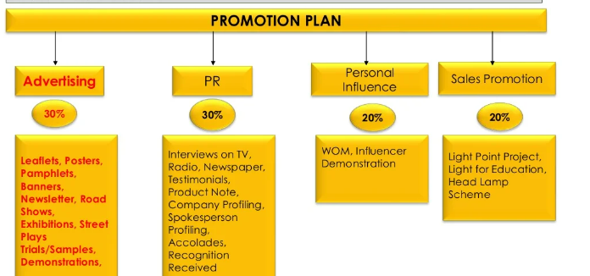

SUGGESTIVE TARGET MEDIA:

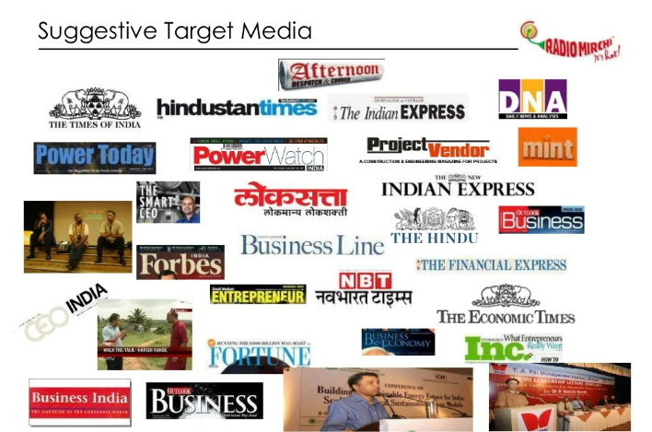

Product Line Expansion
The products of SELCO are manufactured for people for better livelihood and regular sources of money. SELCO can use its impressive capacity for innovation to try developing products.
Reaching out to rural markets requires a bottom-up approach. We have to identify what rural people need, the price points they are comfortable with, demonstrate the use of the product we are selling, and show them why it is relevant to their lives. SELCO India has tremendously worked to solarize the requirements and activities of the people residing in the village areas. Walking on the same footsteps, we plan to increase both the depth and width of the existing product lines by introducing the following products-
Household | - Solar Cooker  - Solar Stove  - Solar Powered Refrigerators  - Solar Mobile Chargers  - Solar Spice Grinding machine
Livelihood | - Solar Boats for coastal regions  - Solar Atta Chakki (Flour Mill)  - Solar powered Fodder/Chaff Cutter Machine  - Solar Tile Cutters  - Solar Powered Axe/ Wood cutter
Institutional | - Solar Food warmer  - Solar Cooler  - Solar ATM

Product Development
We will first build the prototypes, and test them on the following criteria:
- Product Design and Efficiency
- Cost Modelling
- Manufacturability issues
- Value analysis
- Sourcing and Supplier Fit
- Volume Scaling and Production
Due to the existing strong distribution channels and devoted client base, we think the Karnataka market would be the ideal place to explore product line expansion. Customers will acquire new products a bit quick as the product adoption process will be considerably faster in Karnataka. We think Karnataka still has a huge amount of potential to expand since SELCO enjoys great brand recognition and equity there. This paves a way to high conversion rates, a significant growth in the customer base, and a considerably higher return on investment.

Sales Network Expansion and Energy Service Centre Expansion
Sales network expansion and strengthening e-commerce presence goes hand in hand to achieve the desired results. High sales rate can be achieved by targeting the locals and the people residing in the village areas.
To increase sales network, we will use the Bottom-up approach. It consists of estimating sales potential in each village, then going up to village clusters to area to district, accumulating the figures as we go up. This approach depends on sales estimates of salesmen of their clusters, which are accumulated for the rural hub and thereby for the whole district. In this way, one arrives at the organizational sales targets. For this, we need to identify the rural clusters that can be covered up by the salesman and sales office. Clusters should be such that covering villages is facilitated while spending as little time in travelling as possible.

GEOGRAPHICAL EXPANSION
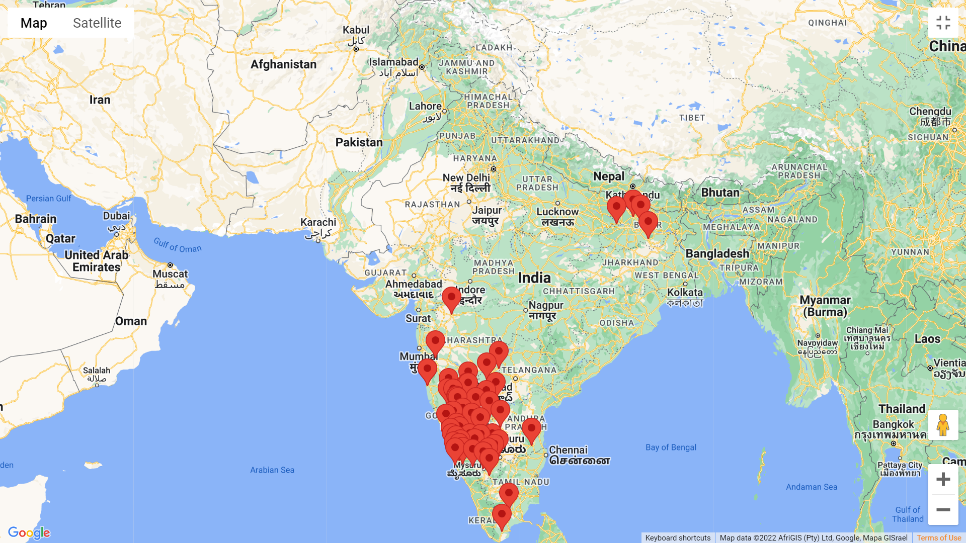

As SELCO India has extensive market in Karnataka, it is suitable for Market penetration and development, new product line launch and market expansion. Bihar, Tamil Nādu, and Maharashtra, Kerala and Andhra Pradesh can be exploited for market development. We would propose to expand the market in other areas as well apart from already established branches. The Hierarchy is as follows:

State Capital | - District Sales Manager: 1  - Area Sales Manager: 15  - Village Cluster Sales Manager: 30  - 500 Villages (40% of total villages in the capital)  - Business Development Associate: 1 BDA managing 10 Salesperson covering adjacent villages for network expansion, lead generation, promotion and customer conversion.  - ESC: 2 in every Tehsil (Capital Region)
Large populated Districts | - District Sales Manager: 1  - Area Sales Manager: 20  - Village Cluster Sales Manager: 40  - 600 Villages  - Business Development Associate: 1 BDA managing 10 Salesperson  - ESC: 1 in every Tehsil
Standard populated Districts | - District Sales Manager: 1  - Area Sales Manager: 10  - Village Cluster Sales Manager: 20  - 300 Villages  - Business Development Associate: 1 BDA managing 10 Salesperson  - ESC: 1 in every Tehsil
Less populated Districts | - District Sales Manager: 1  - Area Sales Manager: 5  - Village Cluster Sales Manager: 10  - 200 Villages  - Business Development Associate: 1 BDA managing 10 Salesperson  - ESC: 1 in every Tehsil
Scarce Populated Districts | - District Sales Manager: 1  - Area Sales Manager: 5  - Village Cluster Sales Manager: 10  - 100 Villages  - Business Development Associate: 1 BDA managing 10 Salesperson  - ESC: 1 in every Tehsil

NEW PROPOSED LOCATIONS:
- Bihar: Gaya, Patna, Chapra, Bhagalpur, Darbhanga
- Kerala: Kochi, Pallakkad, Kozhikode
- Maharashtra: Nagpur, Mahabaleshwar, Kohlapur
- TamilNadu: Coimbatore, Thanjavur, Salem, Kanchipuram, Vellore
- Andhra Pradesh: Nellore, Guntur, Vijaywada, Warangal

OVERALL STATISTICS
- Villages covered in all states: 5000 in all the states
- Households reached (If 300 houses reached per village): 1500000
- Conversion rate: 15%
- New Customers in Year 1: 2,25,000
- Projected customer Growth in next 5 years: 12,00,000 approx.

MARKETING MIX BUDGET BREAKUP
Total Budget utilized: 2 Crores

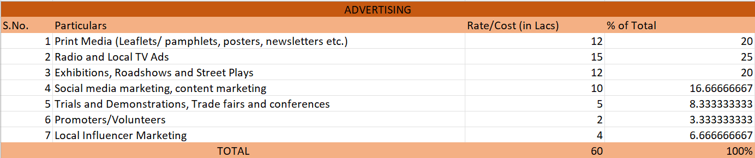
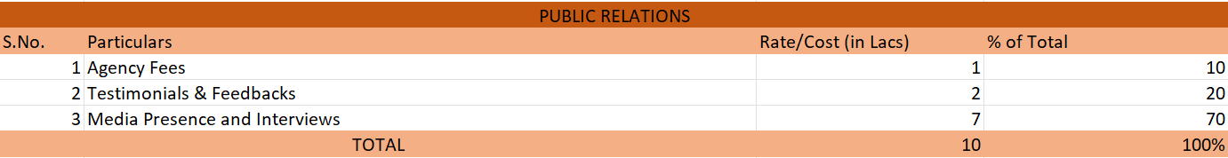
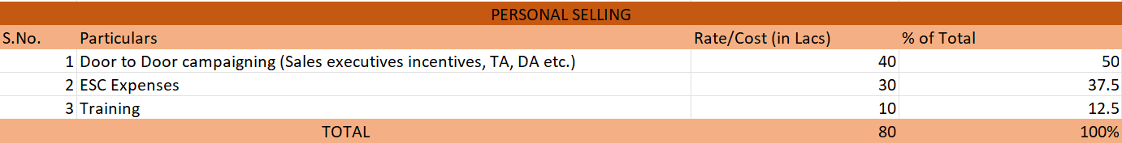
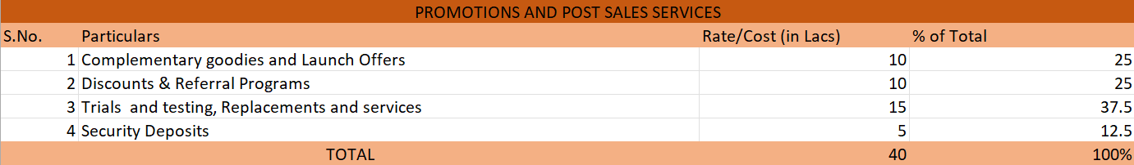

Conclusion

If proper strategy is adopted for product line expansion, sales network expansion and ESC expansion; the desired sales can be achieved. This needs to be pushed by using advertising and promotions with a properly allocated budget. SELCO also needs to focus on training and buffer expenses. With properly executed marketing plan, the objectives can be achieved within 5 years of time frame.

