ASSIGNMENT TAKEN
Strategic Detailed Plan to Convert Waste to Wealth
TITLE
Plan to bring a Positive Turnaround in Bhopal Waste Management System
CASE UNDERSTANDING
The Madhya Pradesh Government plans to build region-based integrated waste management facilities that will serve surrounding ULBs to make trash management procedures in Bhopal more effective and financially sustainable. The project also includes the primary and secondary collection of municipal solid waste (MSW) generated by metropolitan local governments. Madhya Pradesh's government is inviting private sector companies to participate in the design, construction, financing, operation, and transfer of Integrated Municipal Solid Waste Management Projects, as well as to turn Waste into Wealth for the same purpose.
Our company has chosen to participate in the M.P. government's "Waste to Wealth" Scheme for the city of Bhopal. To be considered for this project, our organisation must develop a comprehensive plan and proposal considering marketing, financial, human resource, and I.T. requirements. Considering way to go forward, an PPP model (Public Private Partnership model) as we need to plan complete turnaround.
BCS SOLUTION SUMMARY
“Waste isn’t a Waste until we Waste it”; We as a team -Trash Gold Pvt. Ltd are presenting the solution to practically implement the quote. We, as a company are focussing on creating quality products with the waste and also focus on effectively selling it to end consumers. Solution clearly mentions the expected support from the government body and how we will make this plan practically possible, focus on strong IT infrastructure to have an efficient & smart system; various HR activities – training, Recognition event, reward system; strong omnichannel marketing & trash gold application to encourage segregation at home- all together make a plan for turnaround. Creating Awareness & education people of Bhopal is also an important aspect of our solution. For creating wealth, we are selling products under the brand name – Eco Trendy. Solution clearly mention role of each department and how they will work with collaboration & co-ordination to achieve the goal
SOLUTION
Market Research:
Cities around India face several challenges due to increased urbanisation, and one of the major problems is the rising amount of waste generated. Solid waste generation is one of the three major environmental problems faced by municipalities in the world. Generally, it is positively related to the level of income and urbanization with higher income and more urbanized economies generating higher levels of solid wastes per capita. Rapid population expansion and an increase in living standards have created insurmountable issues for Bhopal's municipal solid waste management (MSWM). The city produces roughly 800 t/d of municipal solid waste (MSW), which is expected to increase to approximately 2735 t/d by 2035. The Bhopal municipality covers 298 square kilometres. Old city- 41.58 Sq. Kms, BHEL -44.18 Sq. Kms, New city- 77.97 Sq. Kms, Village area- 122.15 Sq. Kms. Out of the total municipal area only 77.25 Sq. Kms is classified as the developed area. The rest consist of open spaces, water bodies and other unplanned peripheral areas some of which are being used as a dumping ground for the solid waste. Currently, the waste disposed of in municipality bins also gets transported without segregation by the municipality authority of Bhopal. The waste is later taken to the disposal site at Bhanpur which is located at a distance of 16 kms from the city.
Source of Municipal Solid Waste:
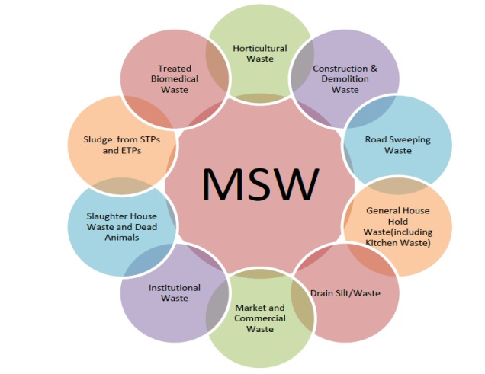
MSW contains compostable organic matter (fruit and vegetable peels, food waste), recyclables (paper, plastic, glass, metals, etc.), toxic substances (paints, pesticides, used batteries, medicines), and soiled waste (blood-stained cotton, sanitary napkins, disposable syringes). Based on research paper, generally MSW composition at generation sources and collection points, determined on a wet weight basis, consists mainly of a large organic fraction (40–50%), ash and fine earth (20–30%), paper (10–15%) and plastic, glass and metals (each less than 1%). Our main focus will be on Market & commercial, household, institutional waste, sweeping waste for “Waste to Wealth”.
Expected Support from Government Body:
We understand bringing a turnaround cannot be done along- we as a company need support of Government, Municipal body and most important citizens. Municipality need to collect all the waste, we as a company will surely support with the technology to make it more efficient and generating better practices. Once collection is done, we takeover the complete process till finish product and selling of it to consumers too. Dustbin Color Coding Sensitization is what we will make necessary in all household and commercial points will help of government body. We also expect monetary support in terms of grants, incentives etc.

Company Details:
Company Name: Trash Gold Pvt. Ltd
Our Mission: “To provide an integrated solid waste management solution to the people of Bhopal by leveraging into the latest technology in solid waste management and enhance quality of life by being a community oriented and environmentally friendly firm.”
Our Vision: “To be a PROMINENT waste management company committed in promoting a CLEANER & HEALTHIER environment to the people and reduce the carbon footprint using innovation”
Brand Name for Retail Product: Eco Trendy
Uniqueness of Our Proposal:
- Using latest technology with strong IT infrastructure.
- Strong focus on becoming completely self-sufficient with initial focus on retail products – a way to “Waste to Wealth”
- Initial Focus of convert paper, plastics and related waste into yarn and fabric consecutively and finally into fashion clothing which includes wearables and accessories. With time, also focussing on fuel production from waste & waste in road preparation.
- Profitable Financial Model, with investment payback period of 5.47 years and IRR for the period - 18.25%.
- Retail Brand Positioning synchronous with current era and trendy in youth.
- Employee salary as per industry standards; efforts for high retention rate.
- Supporting women workforce, collaborating with NGO for hiring ground level employees
- Unique Reward System- “Sant Gadget Baba Award – Youth of India”, Golden Employee Award, Star of the Month Award and various spot awards.
- Strong MIS system to inform all stakeholders about progress and current stage of the project.
- TrashGold Application to increase awareness and improve waste collection
Execution Plan – Department Wise:
- Marketing –
- “Good Marketing makes the company look Smart. Great Marketing make the Customer Smart”, our marketing team has a tech-led plan for the project. Focus on youth, environment conscious people as customers for our retail product.
- Creating a strong Branch Eco Trendy with brand positioning- 100% recycled clothing, in addition to being aesthetic of the same style and quality as other products made with non-recycled products found in the market. Retail Products for men, women as well as children- thus increasing the target group.
- Creating advertising and media presence by using app, social media platforms, newsletters, digital marketing, collaborations and website.
- Feedback from customers given most important and making necessary changes with time

- Finance

- Clearly defining revenue streams- Household Tax Collection, Revenue from Government Schemes, Sale of Recycled finished products, Revenue from other miscellaneous source like compost and Municipal fixed pay.
- Consider complete employee cost by giving salary as per industry standards.

- IT
- The IT department focussed after three significant areas of concern, which include governance of the company's technological systems, maintenance of the infrastructure, and functionality of the systems overall.
- Strong MIS system to help the organisation which will help organisation to take informed decisions and for the coordination, control, analysis, and visualization of information in an organization.
- Strong, user friendly and detailed website of the company as well as retail brand

- HR
- Focus on training & employee growth is priority.
- Unique Reward System- “Sant Gadget Baba Award – Youth of India”, Golden Employee Award, Star of the Month Award and various spot awards.
- Communicating our main motto is to Convert City in a place where people can live a healthy life with Wealth; to make our employees as our Brand Ambassador.

CONCLUSION
Bringing a change in Bhopal waste management system with focus of Waste to Wealth is not a one-day process, but continuous process to be done for years. Innovation is the key with awareness in the public about important of waste segregation. Developing a strong retail brand is very crucial for the project and as day-by-day awareness is increasing the target group size is on rise. Project will be successful if all department work in collaboration and support of government as expected in the solution is rendered 100% timely. This will create sustainable future for Bhopal and will make it a role model for the entire nation. We as a company expect to grab more project in other cities too.

