SELCO – HRM TEAM

INDEX
Assignment Taken-
Title
Case understanding
BCS Solution Summary
Training Plan
Policies
Performance Evolution System
Reward System
Workforce Management

Assignment Taken-
SELCO India is Looking at expansion of its business. Expansion Strategy must include three basic Goals like as follows
- Product Line Expansion
- Sales Network Expansion
- Energy Service Centers Expansion

TITLE –
JOURNEY OF SELCO EXPANSION WITH NEW TEAM

CASE UNDERSTANDING –

SELCO India is a rural energy service company, with its headquarters in Bangalore, Karnataka, India. Established in 1995, to disprove the following 'myths' and over the last 20 years
- Poor people cannot afford sustainable technologies
- Poor people cannot maintain sustainable technologies
- Social ventures cannot be run as commercial entities

Mr.Hande is the founder of SELCO.He has co-founded SELCO India in 1995 (with Neville Williams) to provide solar electricity for lighting and power to India's poor. At starting it goes well. But, during the early 2000s, company has tried to expand its business for which SELCO India created a franchised dealer network, This Attempt hurted company's financials and deviated from its original mission to help the poor. With the help of the World Bank's commercial finance arm, the International Finance Corporation (IFC), Mr. Hande was able to restructure the company in 2008. SELCO India remained a for-profit business, but Mr. Hande was able to seek new investors more aligned with its mission. In addition, Mr. Hande was able to keep his sales and service organization intact, complete with its core of highly motivated employees.
SELCO India's product success is SELCO India's ability to provide a microfinance solution along with its innovative and useful productsSELCO India invested time and cultivated strong partnerships with banks and microfinance organizations in order to provide very creative & efficient financial solutions to assist target population to fulfill their electricity needs and easily repay for their capital investment.

So, now SELCO India is Looking at expansion of its business and this Expansion Strategy must include three basic goals as -
- Product Line Expansion
- Sales Network Expansion
- Energy Service Centers Expansion

BCS SOLUTION SUMMARY –

HRM in Expansion of Organization –
HRM play a critical role in managing employees, helping them to work effectively and creatively to help their organisation to attain a competitive advantage in their market. An HR manager contemplating expansion should consider a number of factors to determine whether expanding HR operations is a timely goal. Factors include cost effectiveness, staff expertise, business growth, change management and employee engagement affect.

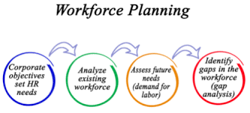

SELCO currently employs about 150 employees in Karnataka and Gujarat spread across 23 energy service centers. Since 1995, we have sold, serviced and financed over 100,000 solar systems to our customers.

And now We HR team are giving our best for expanding Organization in next 5 years.
Human resources are the most valuable and unique assets of an organization. The successful management of an organization's human resources is an exciting, dynamic and challenging task, especially at a time when the world has become a global village and economies are in a state of flux. Expansion of SELCO India would be a successful project only if its human resources are devoted and their aim coincides with the aim of the organization.

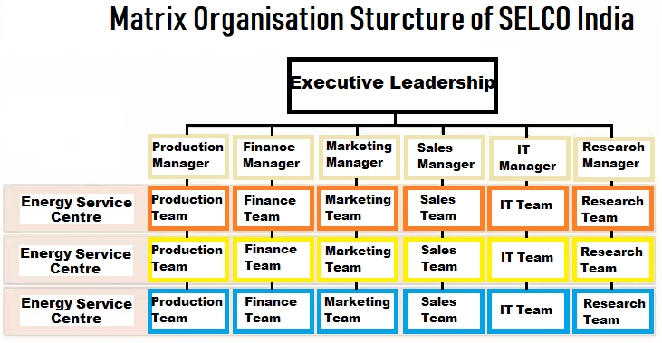

RECRUITMENT –

Sources of Recruitment:

The eligible and suitable candidates required for a particular job are available through various sources. These sources can be divided into two categories, as shown in Figure –

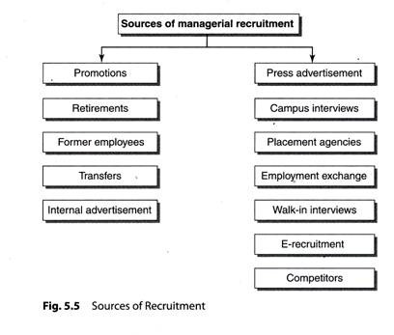

Internal Sources of Recruitment:
1. Promotions:
The promotion policy is followed as a motivational technique for the employees who work hard and show good performance. Promotion results in enhancements in pay, position, responsibility and authority. The important requirement for implementation of the promotion policy is that the terms, conditions, rules and regulations should be well-defined.
2. Retirements:
The retired employees may be given the extension in their service in case of non-availability of suitable candidates for the post.
3. Former employees:
Former employees who had performed well during their tenure may be called back, and higher wages and incentives can be paid to them.
4. Transfer:
Employees may be transferred from one department to another wherever the post becomes vacant.

5. Internal advertisement:
The existing employees may be interested in taking up the vacant jobs. As they are working in the company since long time, they know about the specification and description of the vacant job. For their benefit, the advertisement within the company is circulated so that the employees will be intimated.
Benefits of Internal Sources of Recruitment:
1. The existing employees get motivated.

2. Cost is saved as there is no need to give advertisements about the vacancy.
3. It builds loyalty among employees towards the organization.
4. Training cost is saved as the employees already know about the nature of job to be performed.
5. It is a reliable and easy process.

Limitations of Internal Sources of Recruitment:
1. Young people with the knowledge of modem technology and innovative ideas do not get the chance.
2. The performance of the existing employees may not be as efficient as before.
3. It brings the morale down of employees who do not get promotion or selected.

4. It may leads to encouragement to favouritism.
5. It may not be always in the good interest of the organization.

External Sources of Recruitment:
1. Press advertisement:
A wide choice for selecting the appropriate candidate for the post is available through this source. It gives publicity to the vacant posts and the details about the job in the form of job description and job specification are made available to public in general.
2. Campus interviews:
It is the best possible method for companies to select students from various educational institutions. It is easy and economical. The company officials personally visit various institutes and select students eligible for a particular post through interviews. Students get a good opportunity to prove themselves and get selected for a good job.

3. Placement agencies:
A databank of candidates is sent to organizations for their selection purpose and agencies get commission in return.
4. Employment exchange:
People register themselves with government employment exchanges with their personal details. According to the needs and request of the organization, the candidates are sent for interviews.
5. Walk in interviews:
These interviews are declared by companies on the specific day and time and conducted for selection.
6. E-recruitment:
Various sites such as jobs.com, naukri.com, and monster.com are the available electronic sites on which candidates upload their resume and seek the jobs.
7. Competitors:
By offering better terms and conditions of service, the human resource managers try to get the employees working in the competitor’s organization.
Benefits of External Sources of Recruitment:
- New talents get the opportunity.
- The best selection is possible as a large number of candidates apply for the job.
- In case of unavailability of suitable candidates within the organization, it is better to select them from outside sources.
Limitations of External Sources of Recruitment:
1. Skilled and ambitious employees may switch the job more frequently.
2. It gives a sense of insecurity among the existing candidates.
3. It increases the cost as advertisement is to be given through press and training facilities to be provided for new candidates.
TRAINING PLAN-
Training plays vital Role for future growth of organization and Employees. This will help to generate more revenue, set a best line or example in market, that represent organization in front of clients. To give time to time training is highly recommendable for gaining best results in work and daily life.

We will arrange special training sessions for our all workforce like as-
- Finance Department – Session to use latest finance tools and technology
- Marketing Department – To be more creative in offline and online mode, how to increase sales, How to join new people for Organization’s growth
- IT Department – Latest technologies
- HRM Department – Sessions of Payroll, how to recruit skill employee, People and Time Management, How to utilize resources
- Other Team – Cleaners, Drivers, Waste Segregators – To make them more skillful

The training schedule will be shared to employees through personal call, SMS, mail. These sessions will be join by each are every employee and to check about is the responsibility of HR and respective seniors of that employees.
It’s a amazing chance for all to learn experience people and also use ideas from young people for R&D.
Some more skills training as-
Customer Care And Client Communication Skills
A business cannot flourish without keeping its clients happy. Hence people responsible for representing the company to a client should be good at communication and wooing the clients. It’s not only what you’re presenting to them, but the way in which you offer the product or service makes a significant difference. Hence customers dealing or sales training is one of the most prestigious courses for a company or a business.
Creative Thinking Skills Grooming Program
Employees can only grow and excel in their careers when they are continually thinking something from a newer, different perspective. It helps the company progress in terms of innovation as well as productivity.
Creativity and innovative thinking become all the more critical in a place like Dubai, with a very high influx of people seeking jobs. Owing to this, many businesspeople ensure soft skills training in the workplace for grooming their employees being humans. It is the key to success.
Introduction of some me time period for all employee-
Whenever any employee do a work they do it very much passion. But after some time they workf or only salary because they get bored or mentally disturb while doing continues work.
So, Here I want to launch a new concept which will happen on every Friday in our company which will called as- Friday Party- which include a me time session, learning sessions, creativity sessions, relaxation sessions , hobbies sessions. SO that will help employee to be relax and do work again with more energy and more productivity.
POLICIES :-
1.HR policies-
- Employment contracts
- Wages
- Termination of employment
- Maternity and Paternity leaves
- Prevention of Sexual Harassment at workplace
- Public holidays and work weeks
- Restrictive clauses in employment contracts
- Gratuity and Provident Fund
- Impact of Digitalization
- Adaptive work culture

2. Production Policies-
The Policy of Related Air Purifier Device - Production Department is to manufacture, test and supply product that meets design specifications, to ensure efficiency and quality is maintained and improved where possible, to minimise scrap, wastage and rework and to satisfy customer delivery schedules at all times.
The main aims of the department include:
- To ensure the efficient flow of information and product between the individual production sections (Machine shop, Assembly, Testing and Despatch) as well as with other Related departments.
- To encourage positive communication, improvement suggestions and feedback.
- To identify and satisfy training requirements.
- To identify, satisfy and improve all aspects of Health and Safety.
- To encourage the active general maintenance and cleanliness of working areas, machines and equipment to ensure an effective production environment.

3.Workplace Security Policies-
Policies on security are in place to protect not only the people in an organization, but the physical and intellectual property as well. Policies may cover entrance to a facility, such as the use of ID cards and the procedures for signing in a guest. Equipment such as a company laptop or smartphone may need to be signed out.
PERFORMANCE EVALUATION
For Employee performance evaluation – we are going to use Performance dashboard which is very useful and easy for Employee/Process performance. This contain – Summary, Monthly Performance, Weekly Performance, Agent wise Performance and Supervisor wise Performance.
- Summary-
Speed meter which shows average garbage collection count
Battery which shows daily cleaners, drivers present count
A board which shows daily target performance
- Monthly Performance-
Check attendance, work completion time, feedback from people from where they collect garbage & points collected from Supervisor
- Weekly Performance –
Check attendance, work completion time, feedback from people from where they collect garbage Employee wise performance & from Supervisor
- Supervisor Wise Performance –
Check supervisor individual performance and how to work as leader to get work done from juniors or assigned workers , feedback collected from team members who worked under this respective supervisor.

REWARD SYSTEM
Reward is divided into number of Categories –
- Golden Employee Award – This award will be given to best player from each department
- Star of the Month Award – from each department
- There will be another different awards as well to motivate employee time to time.
Expansion of Organization-
NEW PROPOSED LOCATIONS:
- Bihar: Gaya, Patna, Chapra, Bhagalpur, Darbhanga
- Kerala: Kochi, Pallakkad, Kozhikode
- Maharashtra: Nagpur, Mahabaleshwar, Kohlapur
- TamilNadu: Coimbatore, Thanjavur, Salem, Kanchipuram, Vellore
- Andhra Pradesh: Nellore, Guntur, Vijaywada, Warangal
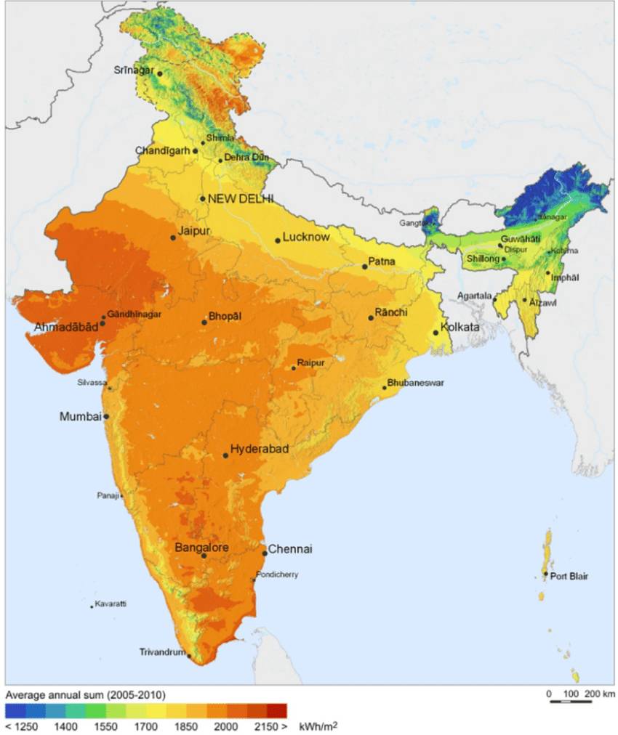

.Workforce Management-
To win in the competition - in todays market we need best Workforce who will be the star of Organization and make organization Vision & Mission successful.
I have mention the workforce that we need for this project – Designation , Education, Role & Responsibility.

Sr No | Department | Designation | Education | Role & Responsibility
1 | Finance | Director | MBA-Finance  Certifications-  CFA,CTP,CPA | responsible for the company's long-term financial health and growth
 |  | Manager | A bachelor's degree is preferred subjects like accounting, economics, finance or business administration | oversee the financial health of an organization and help ensure its continued viability
 |  | Ass. Manager | bachelor's degree in accounting, finance, mathematics | help finance managers with administrative and financial tasks, including invoicing, budget drafting, issuing purchase orders, and implementing and managing procurement processes
2 | Marketing | Director | master degree along with some experience | oversees and stirs marketing strategies and efforts in order to strengthen company's market position and achive desired business goals.
 |  | Graphic Designer | Graphic Design course at the PG level, aspirants should possess a bachelor's degree in design | create visual concepts to communicate information
 |  | Sales Manager | MBA degree in Sales and Marketing | hiring and firing, identifying where training is needed and providing it, mentoring sales reps, and assigning sales territories
 |  | Distribution Manager | a bachelor's degree in distribution management or a similar field, such as logistics, supply chain or materials management | implement systems and plans by analyzing data to improve work execution, distributing tasks, and managing team schedules.
 |  | Digital Marketing Executive  (2 Person) | a bachelor's or Master’s degree in a related field, such as marketing, digital media, communication, website/graphic | planning and managing marketing campaigns that promote a company's brand, products, and services.
3 | IT | CTO | bachelor's degree in IT with 15-20yrs Experience | overseeing the development and dissemination of technology for external customers, vendors, and other clients to help improve and increase business.
 |  | IT Manager | Bachelor's Degree in IT with 8-10yrs experience | Running regular checks on network and data security.
 |  | Developer  (3 Person) | Bachelor's Degree in IT | Researching, designing, implementing, and managing software programs.
 |  | Networking Specialist  (2 Person) | bachelor's degree with CCNA certification | handle installing, configuring, and supporting firewalls to ensure network security
 |  | CRM Manager  (2 Person) | A diploma/degree in sales, marketing, business | to constantly look for ways to better understand the customers' needs and desires, with the purpose of helping the company deliver goods and services that fulfill them.
4 | HR | CHRO | BBA/MBA-HR  With 15-20yrs experience | responsible for running an organization's human capital management and other HR technology systems.
 |  | HR Manager | MBA-HR with 5-6 yrs experience | lead and direct the routine functions of the Human Resources (HR) department
 |  | Recruiter  ( 2 Person) | Bachelor's Degree in Human Resources, Business Administration, or related field. | experts in the finding, screening and attracting of applicants for open positions
5 | Production | Engineering Technician | Engineering in electrical, E&tc | Engineering technicians assist civil, mechanical and environmental engineers and scientists in testing and applying theories to help improve the performance of solar energy-related facilities, processes or equipment
 |  | Electronic Maintenance Technician | Engineering in E&tc | Electronics maintenance technicians monitor solar PV software systems to make sure they are working properly. They help develop, set up and repair electronic or computer-controlled solar energy systems in hub facilities and at equipment sites
6 | Other Staff | Supporting Staff | -Ability to work both alone and in a team.  -Awareness of health and safety procedures.  -Reading skills for following instructions.  -Maths skills for measuring cleaning fluids. | ensures the workplace is always clean and sanitary.

In this Workforce Management-
We are basically focus on Sustainable Growth, women empowerment and provide a job for uneducated people to be a part of wealthy life-style and start life newly.

Estimated Cost –
- Recruitment – 20lack
- Training - 10 lack

CONCLUSION –

In above information HRM team provided what kind of new employees are required for expansion of organization. For expansion of our business we required new creative and innovative ideas by recruiting youth who will give their best for organization’s growth. SELCO also needs to focus on training and buffer expenses. Selco has to give proper and advanced training for old as well as new empyoees and acknolwdge their efforts with time to time awards.

