ASSIGNMENT TAKEN

Business expansion plan for Selco through a collaborative plan of all departments to achieve the goal

TITLE

Business Plan for Selco to become a Brand for Complete “Bharat” for Solar solution & Products

CASE UNDERSTANDING

SELCO is a rural energy service provider based in Bangalore, Karnataka, India. Established in 1995 to disprove 'myths,' and has been doing so for the past 27 years. SELCO provides sustainable decentralised energy solutions for the underprivileged in a way that not only adds value to the end user but also ensures a long-term solution. SELCO made numerous steps to remedy the issue, including giving them with access to clean, pollution-free solar energy. However, considering the average rural household income, it becomes an economically unviable option. Mr. Harish Hande was able to restructure the business in 2008 with the help of the International Finance Corporation (IFC), the World Bank's commercial finance section, after experiencing financial losses in the initial years. SELCO India remained a for-profit organisation, but Mr. Hande was able to locate new investors who were more supportive of its goals. Additionally, Mr. Hande was able to maintain his sales and service business, including its core of highly driven workers. Given India's diverse population, where 40 crore members of the low-income category are still unable to avail benefits of accessible and sustainable energy solutions, SELCO India needs to expand its reach. This gap necessitates that SELCO India's services be expanded and scaled up to provide the advantages of solar energy to more people. Without compromising its mission to serve India's underprivileged population, SELCO seeks to expand its business. We have to suggest the best options for expansion for Selco as SELCO India's Current reach was not enough.

For the same, we have to come up with a comprehensive Business plan comprising of Marketing, IT, Finance & HR department plan to bring the dream of expansion in reality.

BCS SOLUTION SUMMARY

We are providing a solution which align with Selco India’s Vision: “Delivering Last Mile Sustainable Energy Solutions that Improve Quality of Life and Socio-Economic Development for the Poor”. Focus on matrix-based organisation structure is a major suggestion in HR strategy. Better customer service with strong IT infrastructure is need of hour with the expansion plan. We have proposed new geographies and new product expansion in household, Institutional and Livelihood in our solution.

SOLUTION

Selco Philosophy

* Tacking affordability with financing matched to cash flows
* Does not fit a solution to a problem
* Scaling Impact vs Supersizing
* Poor as Partners
* Investing in its people
* Investment journey to achieve financial sustainability and retain its social mission

We have focussed our solution in line with all about philosophy of the company.

Energy service Centre expansion

1. Currently there are 67 energy centers of Selco in India
2. We expect energy service centre expansion in below mentioned geography where we are proposing expansion of the product sales.
3. Collaboration and common energy service center with companies in same business line is a profitable way to go forward, considering we are targeting huge expansion

GEOGRAPHICAL EXPANSION

Currently, Karnataka is SELCO India's largest market, making it ideal for market penetration, product line launches, and market expansion. For the growth of the market, Bihar, Tamil Nadu, Maharashtra, Kerala, and Andhra Pradesh might be utilised.

Reason for selecting the above location is:

1. Expansion in southern & western part of India will be easy as compare to northern India.
2. As the target market is middle & lower-income group, Bihar is a good market- as it has lowest per capita income in India.

New Proposed Locations:

1. Bihar: Gaya, Patna, Chapra, Bhagalpur, Darbhanga
2. Kerala: Kochi, Pallakkad, Kozhikode
3. Maharashtra: Nagpur, Mahabaleshwar, Kohlapur
4. Tamil Nādu: Coimbatore, Thanjavur, Salem, Kanchipuram, Vellore
5. Andhra Pradesh: Nellore, Guntur, Vijaywada, Warangal

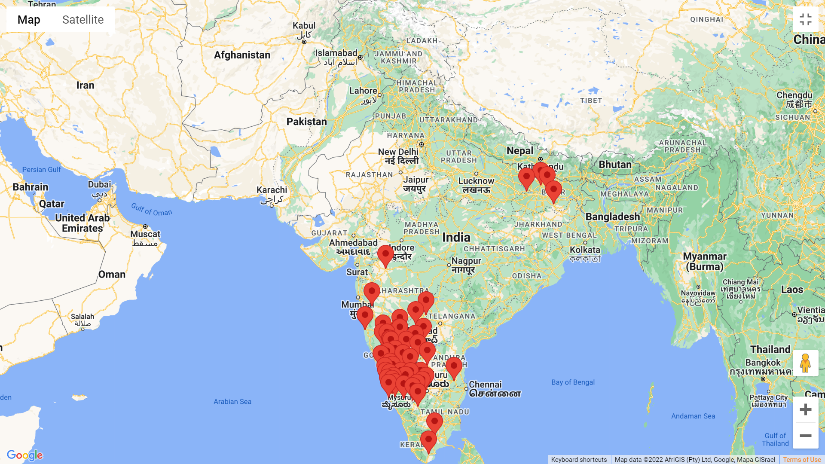

Product Line Expansion

Based on thorough research, we have come up with below product as part of our business strategy- product line expansion.

|  |  |
| --- | --- |
| Household | * Solar Cooker * Solar Stove * Solar Powered Refrigerators * Solar Mobile Chargers * Solar Spice Grinding machine |
| Livelihood | * Solar Boats for coastal regions * Solar Atta Chakki (Flour Mill) * Solar powered Fodder/Chaff Cutter Machine * Solar Tile Cutters * Solar Powered Axe/ Wood cutter |
| Institutional | * Solar Food warmer * Solar Cooler * Solar ATM |

Detailed information about Household product

Solar Cooker: A solar cooker is a device that heats, cooks, or pasteurises beverages and other food items using the energy of direct sunlight.

Solar Stove: It is a device that harnesses sunlight as a source of heat for cooking foodstuffs.

Solar Powered Refrigerators: A solar-powered refrigerator is a refrigerator which runs on energy directly provided by sun, and may include photovoltaic or solar thermal energy.

Solar Mobile Chargers: Solar cell phone chargers use solar panels to charge cell phone batteries.

Solar Spice Grinding machine: It consists of grinding wheel, solar panel, battery, motor etc., The grinding wheel are fixed on a motor shaft. The battery, solar panel and grinding wheel arrangements are mounted on assembly box. The solar panel generates the power supply from direct sunlight. Then the generated energy is stored in the batteries. The store energy in the battery is used to run the motor.

Strong IT Solution

Our strong IT department suggestion is need of our hour- as the lower income group is also using internet and other IT services majorly. Maintenance and repairs, project planning and monitoring, site surveys, and inspection management will be carried out by the IT department with digital transformation across the company.

IT department will also develop an Android App,which can be used by consumers to manage a solar-powered product, inbuilt dashboard that shows current charging data, real time energy generation by solar panels and other useful information in real time. It will be a value add to the end consumer.

Reports and a dashboard detailing Sales, Client target area, Product efficiency, Customer contentment, Sales forecasts, and Insights from analysed data may be generated with the use of Management Information software. It will be useful for Senior management to take real time decision and help business move in proper direction.

HR Strategy:

Keeping our solution align with the Selco Philosphy, we will focus on recruiting local talent more till entry and middle management clearly based on merit only. The majority of the newly recruited workforce would consist of the local plumbers, electricians, engineers, etc belonging to the villages nearby the ESCs. Utmost preference would be given to the local villagers. Partnerships can be initiated with village influencers and panchayats who would facilitate in creating awareness among the villagers and making them interested towards working with SELCO

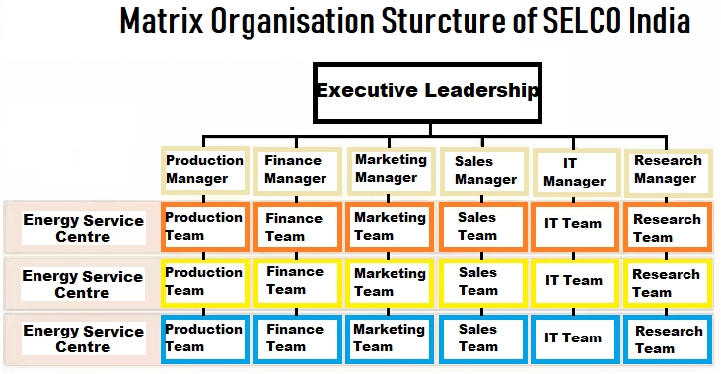

TRAINING AND DEVELOPMENT

CONCLUSION;

Based on our recommendation, if it is implemented, we expect at least 2.5X in terms of increase in consumer base, in next 3 years. Our strong HR strategy and focus on local talent, will help to control attrition. Also, company have to focus on government subsidy that have synergies with our project.