Assignment
Taken Develop and submit a financial plan for international expansion, including a budget allocation.

Case Understanding
Ramalingam Foods started in 1965, when they opened their first restaurant. They evolved from a tiny eatery to a batter manufacturing company to a powdered mix production factory over the years. During this time, they have also significantly increased their product offering. With an eye on worldwide expansion, the company has retained the services of a consulting firm to develop its expansion strategy. The following issues were discovered in the finance segment while developing a growth strategy: Optimal use of the INR 50 crore to ensure steady expansion followed by profit generating. Budget distribution to several ministries to ensure their smooth operation during this process Estimating sales and income in the countries selected for expansion in order to determine production capacity and future plans Estimating the pricing of commodities in the new country based on the country's current economic situation. Choosing the percentage of revenue to be spent for marketing expenses. Determine the level of automation needed in the production plant.

BCS Solution Summary

The company intends to strongly penetrate the market by covering all critical aspects with the 50-crore set aside for expansion. The company intends to earn a revenue of 30 crores in the first year by exporting from Indian manufacturers to the five South Asian countries (Singapore, Myanmar, Indonesia, Thailand, and Malaysia) (from international markets). Manufacturing costs the most (10.5 crores), followed by marketing and wages. The 30-crore revenue is expected to generate an operating income of 6.3 crores and a net income of 1.8 crores. A reasonable distribution of Ramalingam Foods' 50-crore allotment for expansion is found. The allocation prioritizes factory and land, followed by operating capital. In the coming year, factories will be established abroad to increase sales and lower export costs.

Solution

Sales & Revenue
The company's sales target for the first year is 30 crores from all five nations combined. This decision was made based on two factors: the current production capacity of the facilities in India and a 5-7 percent market penetration in foreign markets (the 5 countries). The monthly sales target rises from 28k units (April FY '18-19) to 3.2 lakh units (March FY '19-20). This is a monthly gain of 25%. Such expansion is to be expected given that we are entering an FMCG sector with a largely untapped client base. Our primary target demographic will be the Indians who live in these countries. Once the factories are established in international countries, the revenue from those markets will be significantly higher. This will be due to lower labor expenses and lower transportation costs.
Because these countries' living conditions are similar to India's, the cost of existing products have remained about the same. Because the export expenses are not prohibitively high, there is no need to increase the markup on existing products. In addition, two new goods will be presented in each of the five nations. These items' pricing will be slightly higher than those of existing products:
- 200 grams- Rs. 111
- 500 grams- Rs. 249
- 1000 grams Rs. 486
Product Categories | Name | Weight | Price
1 | North Indian dishes Instant Mix | 200 Gms | 89
2 | North Indian dishes Instant Mix | 500 Gms | 199
3 | North Indian dishes Instant Mix | 1000 Gms | 389
4 | Desert Mixes | 200 Gms | 110
5 | Desert Mixes | 500 Gms | 249
6 | Desert Mixes | 1000 Gms | 499
7 | Chutney Powder | 200 Gms | 75
8 | Chutney Powder | 500 Gms | 199
9 | Chutney Powder | 1000 Gms | 329
10 | South Indian Instant Mix | 200 Gms | 89
11 | South Indian Instant Mix | 500 Gms | 199
12 | South Indian Instant Mix | 1000 Gms | 389
13 | Instant Coffee Mix | 200 Gms | 149
14 | Country Specific 1 | 200 Gms | 111
15 | Country Specific 1 | 500 Gms | 249
16 | Country Specific 1 | 1000 Gms | 486
17 | Country Specific 2 | 200 Gms | 111
18 | Country Specific 3 | 500 Gms | 249
19 | Country Specific 4 | 1000 Gms | 486

Revenue from product type as a percentage of total revenue:
We aim to push the existing product line, with those products accounting for 90% of revenue and the newly announced country-specific products accounting for 10%. South Indian cuisines will comprise around 40% of the present items, while the north Indian mix will contribute 30%. The specifics are listed in the table below.

Product Type | Revenue Percentage
North Indian dishes Instant Mix | 30%
Desert Mixes | 10%
Chutney Powder | 7.5%
South Indian Instant Mix | 40%
Instant Coffee Mix | 2.5%
Country-Specific | 10%

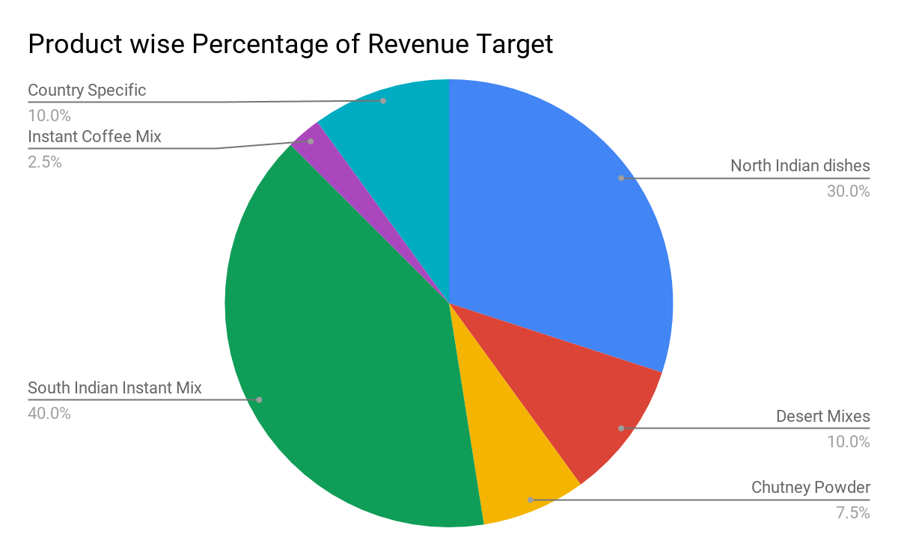

Country-wise split of Revenue Estimate
The five nations chosen for expansion differ in terms of characteristics such as client target size and living levels. Singapore, for example, was ranked one of the world's most expensive cities in a 2019 survey by The Economist Intelligence Unit. According to the 2019 Big Mac Index, Malaysia and Indonesia have the cheapest cities (Big Mac index is a measure of purchasing power parity- comparing countries based on cost of living). The entire revenue projection from each of the five countries is determined by the Indian population.
Country | Population of Indians | Country-wise projected Revenue | Revenue compared to total revenue
Singapore | 5.1 | 2.59762309 | 8.658743633
Myanmar | 29 | 14.77079796 | 49.23599321
Indonesia | 2.3 | 1.17147708 | 3.904923599
Thailand | 2.5 | 1.273344652 | 4.244482173
Malaysia | 20 | 10.18675722 | 33.95585739
Total | 58.9 | 30 | 100

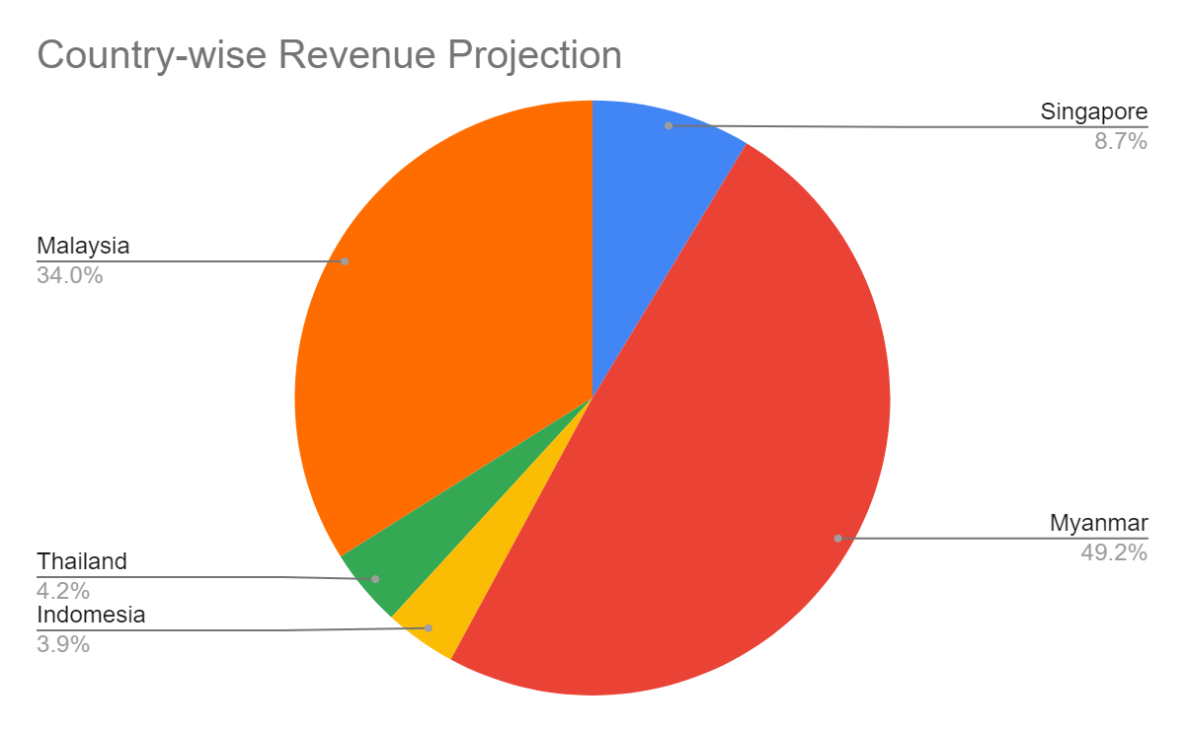

Sales Target for FY'19-20
A sales target (quantity) has been established based on the above revenue projections. The major assumption here is that 200 grammes, 500 grammes, and 1000 grammes are sold in the following proportions: 2:2:1. This assumption is based on the idea that customers want to buy smaller packets more frequently. The sales targets are calculated based on the size of the target consumers in each country. Based on a 5-7 percent market penetration, a monthly growth rate of 25% has been estimated.
FY'19-20 | Sales Target
April | 29224
May | 36530
June | 45662
July | 57078
August | 71347
September | 89184
October | 111480
November | 139350
December | 174187
January | 217734
February | 272168
March | 340210
Total | 1584153

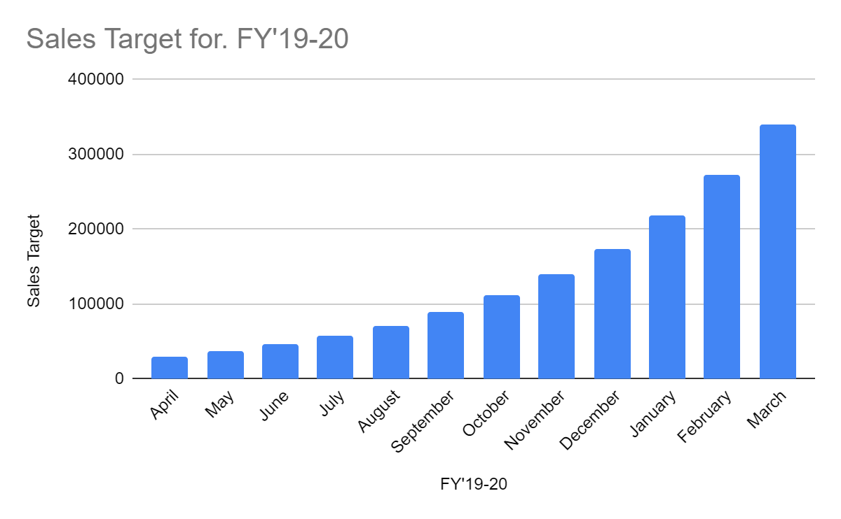

Note: A 25% of Month-to-month growth is projected, considering the market size and penetration rate. Complete calculations can be found in the attachments.

Running Expenses

Cost of manufacturing
This cost includes the cost of raw materials as well as the routine maintenance of factory machinery. Production in existing facilities will be enhanced (if factory utilisation can be increased) and additional quantities will be produced for export. As a result, this cost may be properly estimated because the corporation has previous manufacturing data. Increased labour and machine capacity in each factory can aid in achieving better economies of scale. This enhanced production in current factories will also aid in market capture, while a new facility in a foreign country will be established in one year. As a result, by the time the plants are operational after a year, there will be a high level of demand in worldwide markets. So, going for exports in the first year and subsequently establishing factories in other nations is a viable option.

HR - Salaries
Each corporate office in each of the five cities has 5 employees. The office's head will be paid $75,000 a month, while the others will be paid $60,000. This number was determined by taking into account the cost of living in different nations. The salaries were determined by taking the countries' purchasing power parities (PPP) into account. Thailand, Malaysia, and Indonesia Singapore and Indonesia have PPPs that are roughly comparable to India's. This indicates that the cost of living in these countries is nearly the same as in India, and hence the salaries appear reasonable. Singapore, on the other hand, is an exception, and employees there will be paid more. India's factories require more labour to create and export items. As a result, 40 workers are hired as labourers (assuming that the current factory's capacity can be raised).
Note that calculations will now be done in rupees due to roughly equal PPPs, as well as to maintain uniformity and ease of calculation. Currency conversions can be used to create country-specific budgets by converting units to the country's national currency.

Marketing and Advertising Expenses
Traditional and digital marketing tactics will be used in the marketing. Because the brand name would be unfamiliar to the target clients, marketing and advertising expenses are projected to be greater. Because the company is a new entrant in the worldwide market, even a 5% market penetration necessitates a substantial investment. Marketing, advertising, and promotion are allocated a budget of 4.5 crores with a revenue objective of about 30 crores (15 percent of revenue). Traditional marketing will primarily consist of television commercials, out-of-home promotions such as billboards, and newspaper adverts. Social networking, website design, and video advertising are examples of digital means. It should be noted that TV commercials are expensive and will account for a significant portion of the marketing budget. Marketing has been allocated a budget of 4.5 crores (approximately 15% of revenue). This is critical because the company is entering a new market with multinational competitors such as MTR as well as local competitors.

Export and operation expenses
The export agent and distributors will be compensated for the costs of export and transportation. Because the company will not have factory output for the first year, a full-time logistics workforce is not required. If necessary, we can engage hourly labour in international nations. This will be less expensive than hiring a full-time logistics and operations team. Another benefit of local suppliers is the solid supply network they have developed in these countries' food industries. Waterways are a very cost-effective mode of transportation that reduces transportation costs. The company's export partners and distributors in other nations lessen the need for staff. This expense is budgeted at about 5% of revenue, or 1.5 crores.

Legal Costs- Licenses and Tax
Permissions have one-time expenses such as: • IEC Import-Export code, • FSSAI License, • NOC Certificate, • RCMC (Registration cum membership certificate)
• Singapore-accounting and corporate regulatory authority (ACRA) • Malaysia-Suruhanjaya Syarikat Malaysia (SSM) • Thailand Ministry of Commerce • Directorate of Investment and Company Administration (DICA) • Indonesia Investment Coordinating Board
In addition, the countries have a 6-8 percent GST that comprises cost, insurance, and freight (CIF) as well as other chargeable fees. It is worth noting that the FTAs that India has signed with ASEAN countries have resulted in lower excise taxes and customs duties. As a result, the GST tax will be the primary expense paid to the foreign government.
For Indian government taxes, all income, whether from domestic or foreign sales, is taxed at a corporate tax rate of 22%. (since the total operating revenue is less than 250 crores- 150 from domestic sales and 30 from foreign sales). This effectively amounts to a tax of 25.17 percent on the operational profit, including cess and surcharges (for manufacturing enterprises in India).

Other Expenses

IT Front
IT investment is critical since data management and IT solutions have shown to be game changers in cost reduction. As a large corporation with operations in five countries, big data analytics and cutting-edge IT software/systems are prioritized. The expenses for the IT Department are shown in the table below.
Department | Name of Software | Total Price
Business Expansion and Marketing | AI based servers (Microsoft Azure) | 1,26,380
 | Hadoop | 8,52,000
 | Mobile App and Website Designing | 10,00,000
 | Cloud based ERP | 2,62,487
Finance Department | Financial Management Software | 11,36,000
HR | HR Cloud | 1,01,672
Business Advisory | Cloud Based Transport Management System | 1,50,000

Rent and other HR Costs:
Monthly rent payments for the five corporate offices will be translated into rupees using currency exchange rates. Singapore is assumed to have a greater rental charge, as is done for wages. To allocate budget, sufficient funds based on average rent for working space are used. A total of 20 lakhs has been set aside for hiring and incentive charges.

Miscellaneous and Overheads:

Because the company is expanding into new markets and expenses are unclear, a 5% overhead and miscellaneous charge on revenue is accounted for. A manufacturing plant may also have other charges, and supply chain complexities may add to the other costs.

Expenses Summarised
Expense Category | Amount Estimate (in crores)
Cost of manufacturing | 10.5
Marketing | 4.5
Salary | 3.8
Rent | 0.4
Other HR Costs | 0.2
Exports and operations expenses | 1.5
Tax | 4.5
Miscellaneous & Overheads | 1.5
IT | 0.3
Permissions and Licenses | 1.0
Total | 28.2

50 crores Budget allotment
Investment | Budget allocation (in crores)
Working Capital | 10
Marketing | 4.5
R&D | 5
Land and factory | 20
VC Investment | 7.5
Machinery | 3
Total | 50

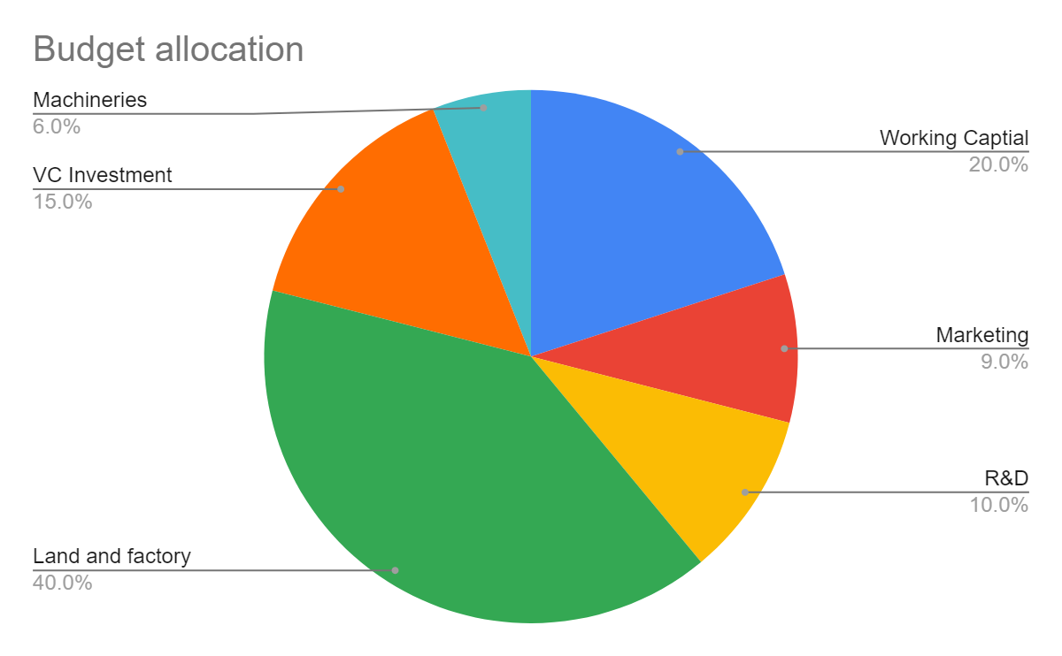

The above allotment has been made by taking various factors into consideration:
- The working capital (10 crores- approx. 30% of the gross revenue of 30 crores from foreign market) is necessary to maintain the liquidity and boost the export operations for first year.
- Land and factory- the biggest investment of 20 crores- is for the purpose of setting up 3 factories (approx. cost of one factory and its machinery is 6.6 crores) in these countries.
- Marketing has a budget of 4.5 crores (15% of 30 crore gross revenue from international market), to boost the company’s visibility in foreign countries and use numerous means of advertisements.
- The machineries have a budget of 2.5 crore- to ramp up current production in Indian factories for export by installing machines and increasing factory utilization.
- Venture capital investment or start-up fund of 7.5 crores is meant for investing in in food-related companies in the south Asian countries. The start-up fund will help the company to strengthen its presence in the foreign country and expand with more products aligned with local taste of the country.
- Lastly, a 5-crore investment in R&D can help to develop new products and remain competitive at all times. An R&D team can be constituted with industry scientists, engineers and market analysts.

Conclusion
Certain assumptions have been used in the calculations above, which are listed underneath. Ramalingam Foods' expansion process can be sped up by keeping a detailed record of predicted revenue and costs. A budget of 50 crores has been set aside to address all of the critical components of growth in such an industry.

